 | Geelong Brush Dustpan And Brush Set | $ 2.5 | 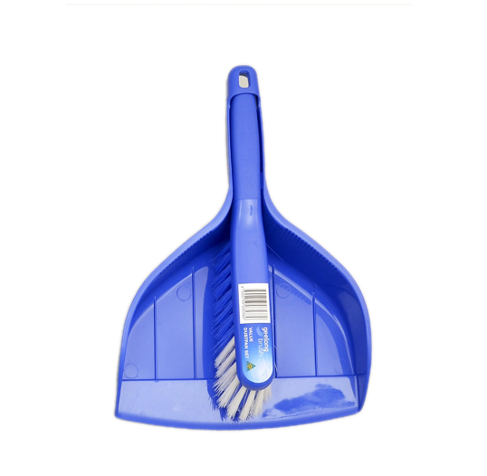
 | Stanley 8m Control Lock Tape Measure | $19.97 | 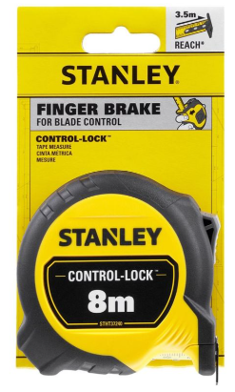
 | DeWALT 18V 4Ah XR ATOMIC 3 Piece Combination Kit DCZ300M2T-XE | $499.00 | 
 | Craftright 230mm Magnetic Torpedo Level | $2.99 | 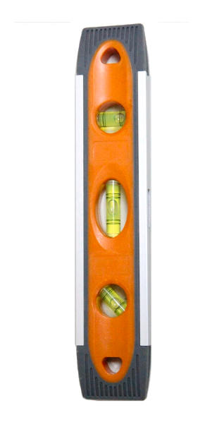
 | Sutton Tools 10 Piece Bi-Metal General Purpose Holesaw Set | 138.00 | 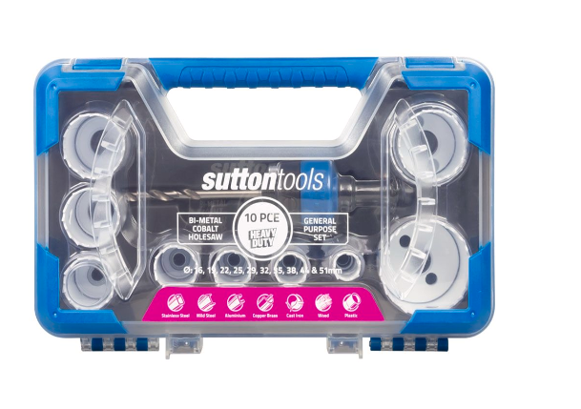
 | Craftright 480mm 19 Pocket Tote Tool Bag | 42.00 | 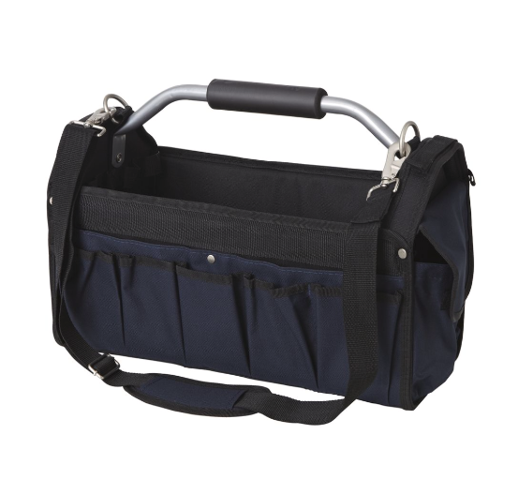
 | Craftright 70 Piece Screwdriver Set | $29.98 | 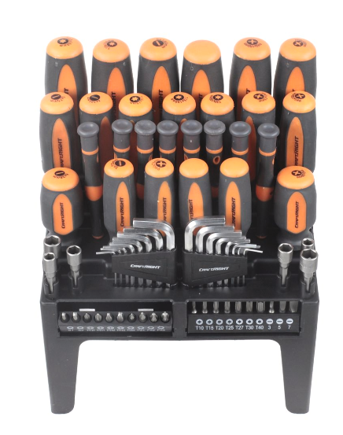
 | Ryobi 19 Piece Metric High Speed Steel Drill Bit Set | $29.98 | 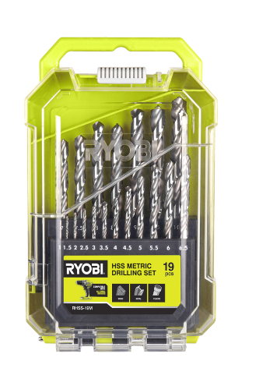
 | Trojan 200mm Adjustable Wide Mouth Wrench | $19.98 | 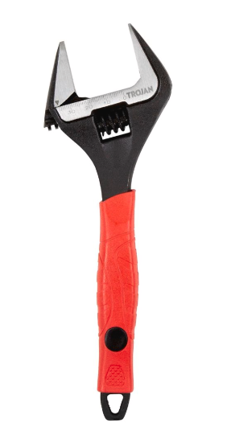
 | Full Boar 1/4", 5/16" & 3/8" Magnetic 67mm Impact Nut Setter Set | $16.98 | 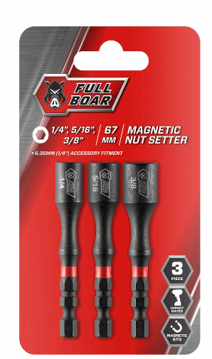
 | Irwin Impact Pro Performance 152mm PH2 - 2 Pack | $10.48 | 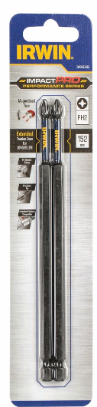
 | Craftright 3 Piece Plier Set | $6.98 | 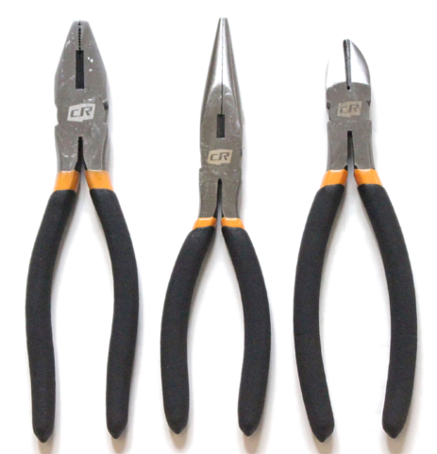
 | Craftright 18mm Snap Off Knife | $1.98 | 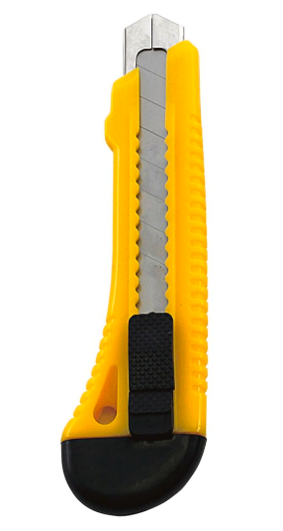
 | Brenniston Complete Workplace First Aid Kit | $101.00 | 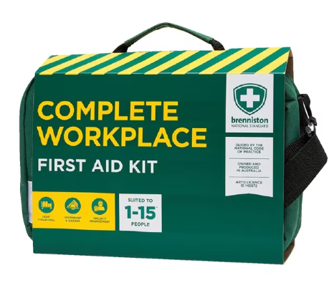
 | Trafalgar ABE Fire Extinguisher 1kg Red | $34.99 | 